**MICROPROCESSOR AND COMPUTER ARCHITECTURE LABORATORY**

**UE19CS256**

**4TH SEMESTER, ACADEMIC YEAR 2020-21**

|  |  |  |
| --- | --- | --- |
| **Name: Atul Anurag** | **SRN: PES2UG19CS075** | **Section: B** |

**Date: 04-03-2021**

**Week#6**

Program Number: 1

1. **Write an ALP to blink LEDs. First, the right LED is switched on and the left LED is switched off. After 1 second, the right LED is switched off and the left LED is switched on and the program continue to blink both the LEDs.**
2. ARM Assembly Code

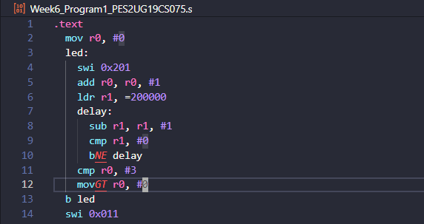

1. Output Screen Shot **(screenshot was taken while the program was running)**

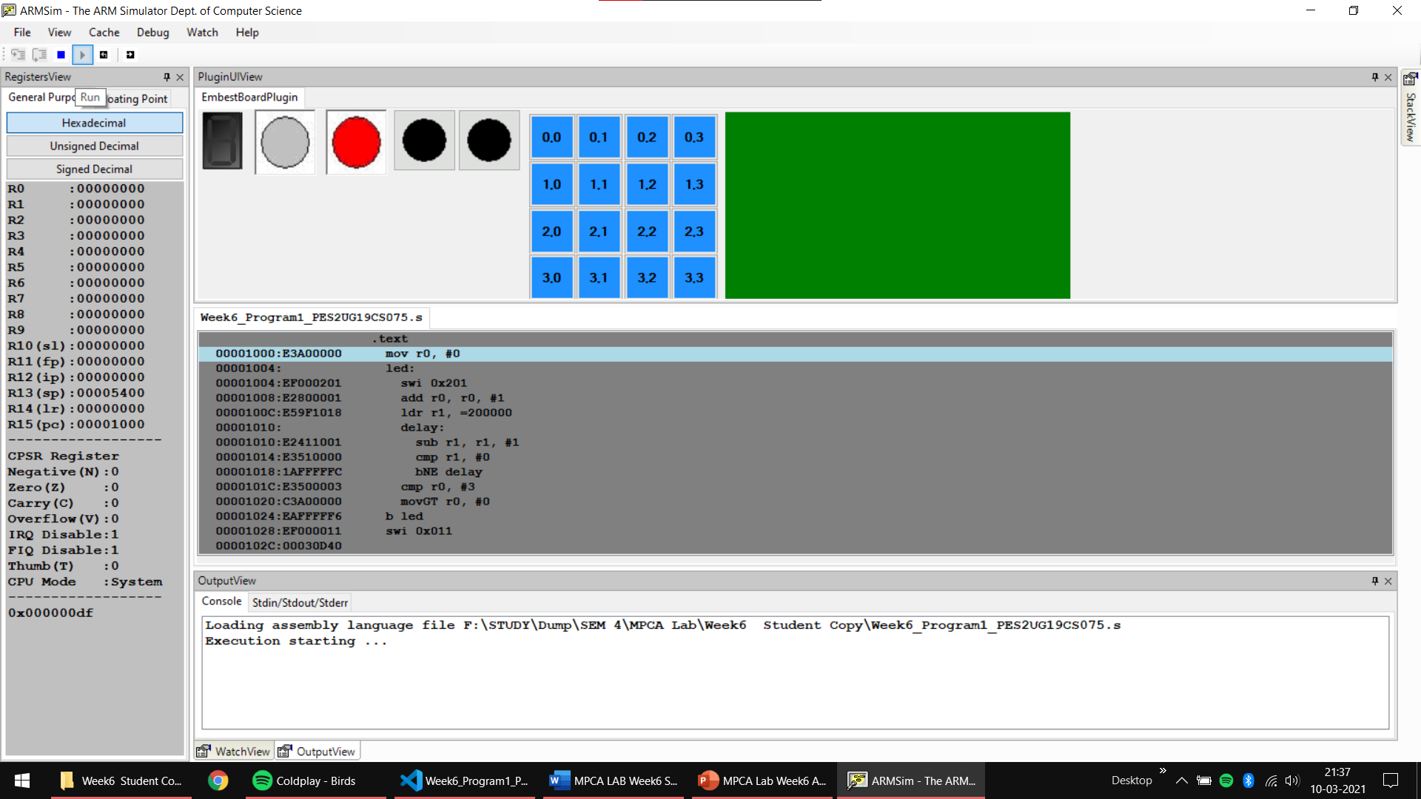

Program Number: 2

**Write an ALP to display 0-9, A-F (up and down count) on an 8-segment display**

1. ARM Assembly Code

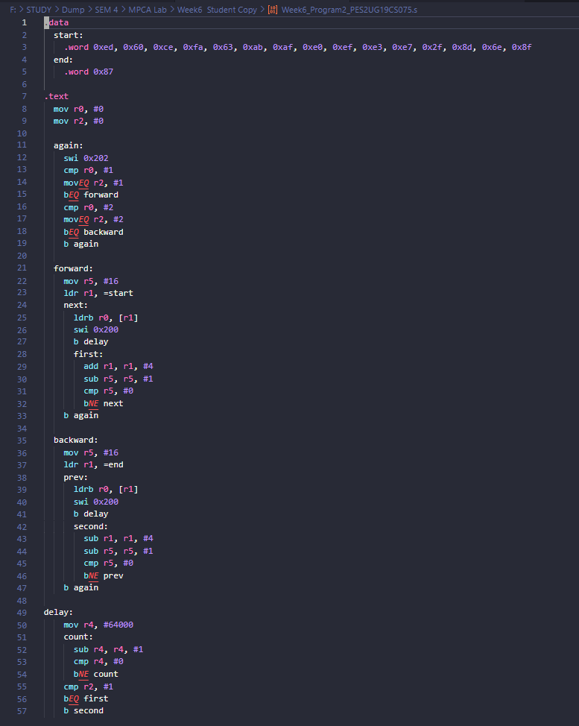

1. Output Screen Shot **(1st screenshot is up count when button 1 is pressed, 2nd screenshot is down count when the button 2 is pressed, both screenshots are taken when the sequence ends)**

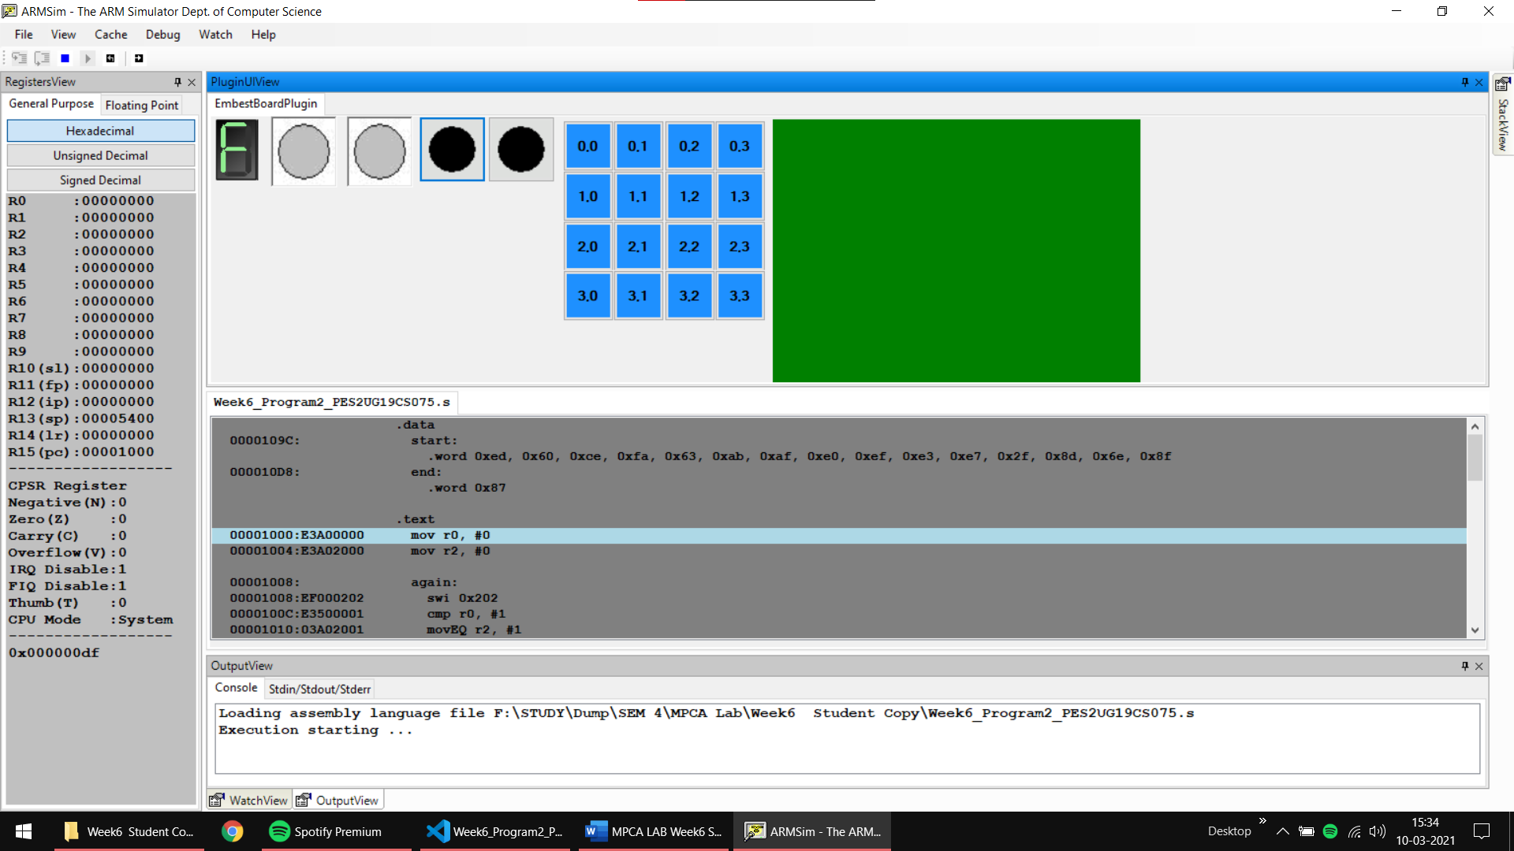

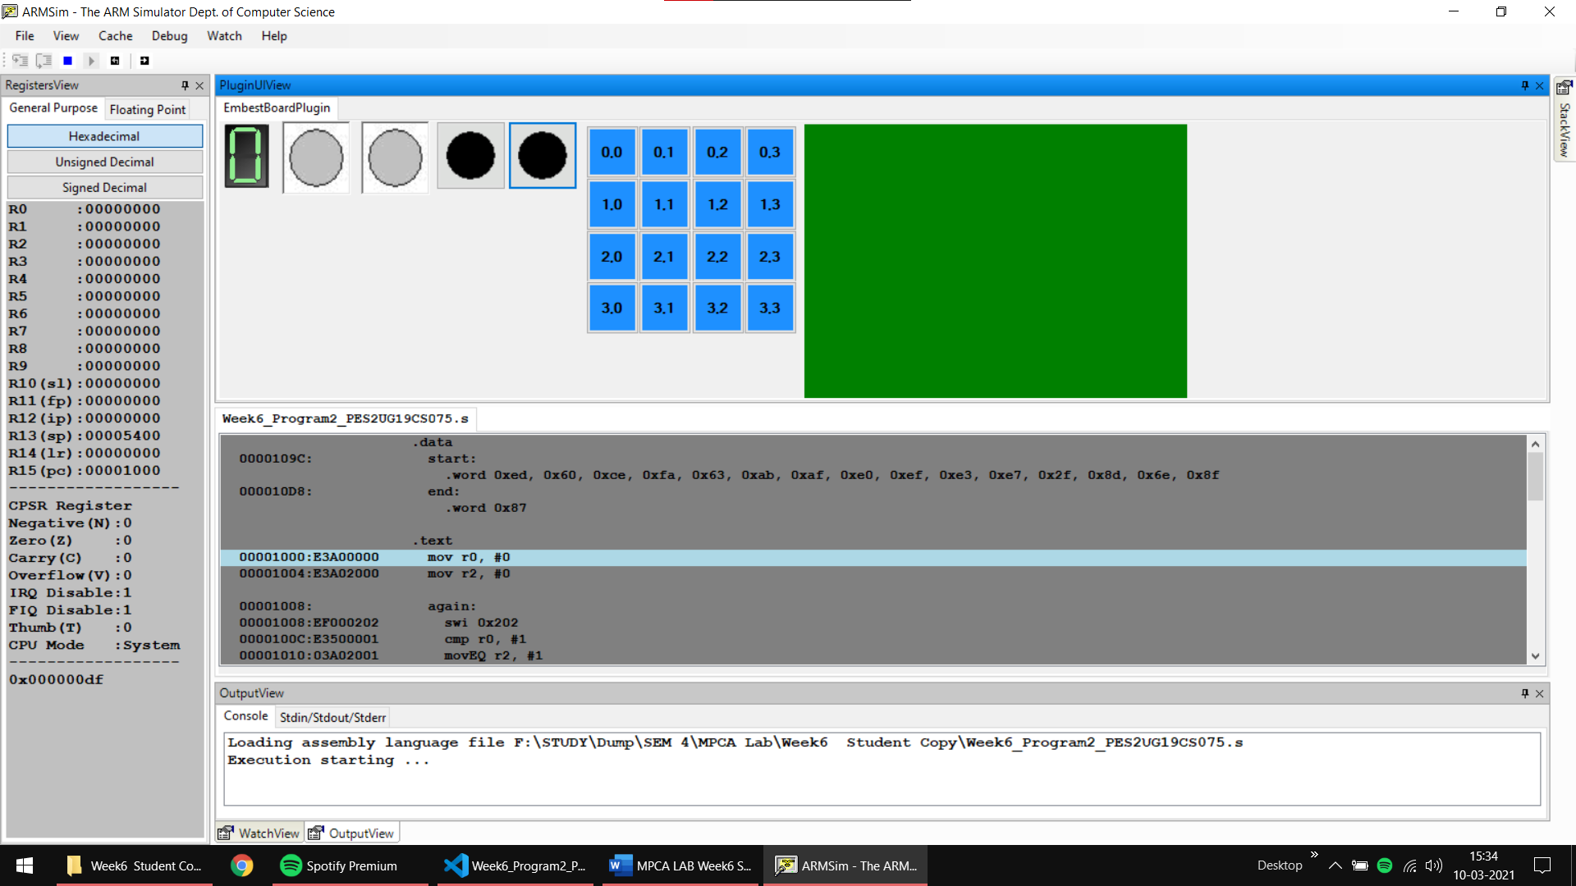

Program Number: 3

**Write an ALP to move a string from Right to Left on LCD**

**(40 columns by 15 rows).**

1. ARM Assembly Code

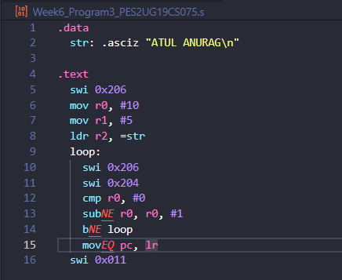

1. Output Screen Shot **(screenshot taken after the program ends after the string moves from (10,5) to (0,5))**

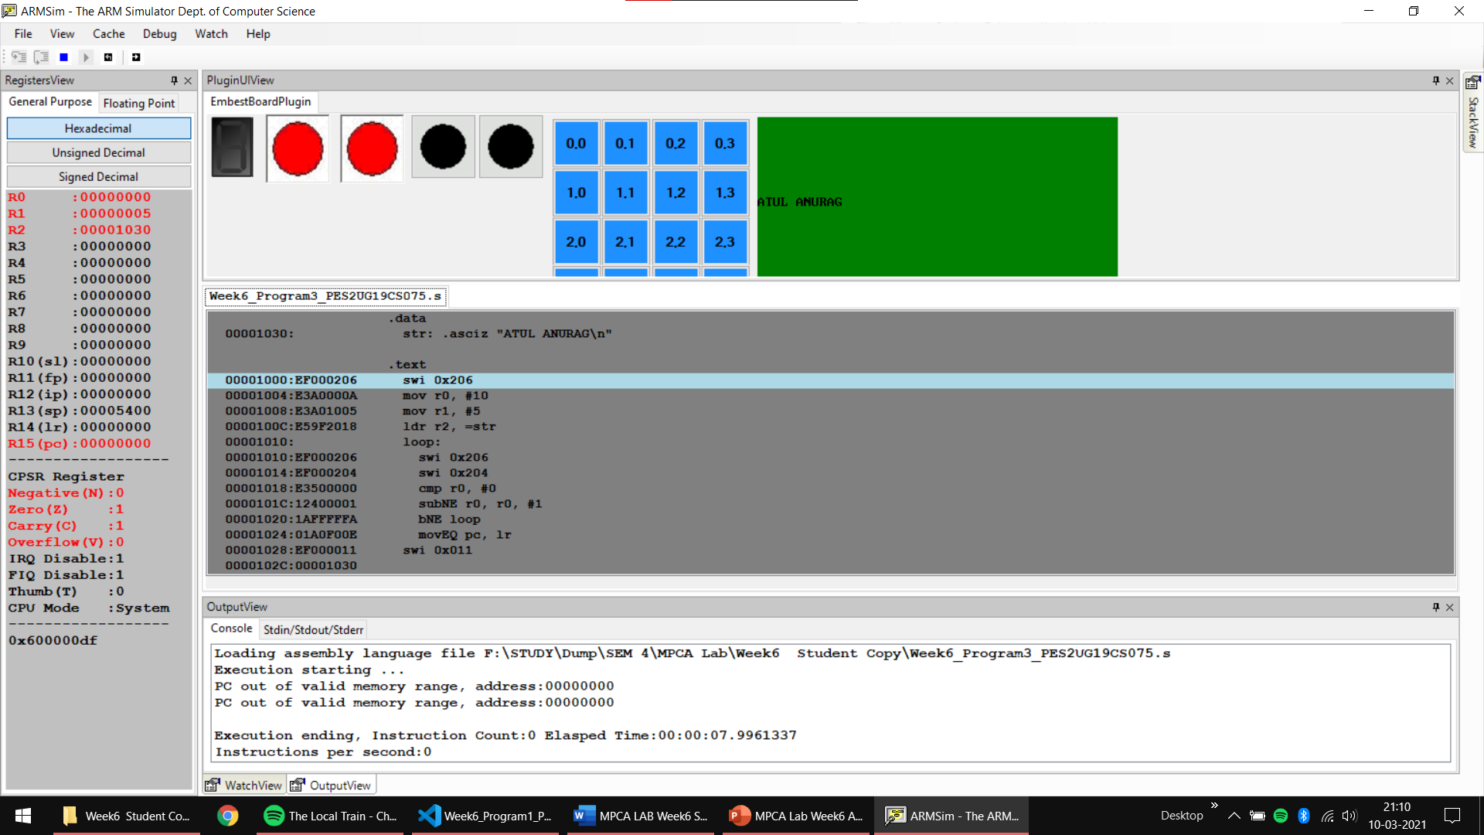

**Disclaimer:**

* The programs and output submitted is duly written, verified, and executed by me.
* I have not copied from any of my peers nor from the external resource such as internet.
* If found plagiarized, I will abide with the disciplinary action of the University.

Signature: Atul Anurag

Name: Atul Anurag

SRN: PES2UG19CS075

Section: B

Date: 04-03-2021